**Plastic Welder Controller**

Derek Syme

June 2018

**System Identification**

A step input applied to the system with varying duty cycles gave data curves that would help experimentally identify the system transfer function. An Arduino test sequence would apply the given duty cycle for 300 seconds and record the temperature. A Matlab script would receive the results communicated through the serial port.

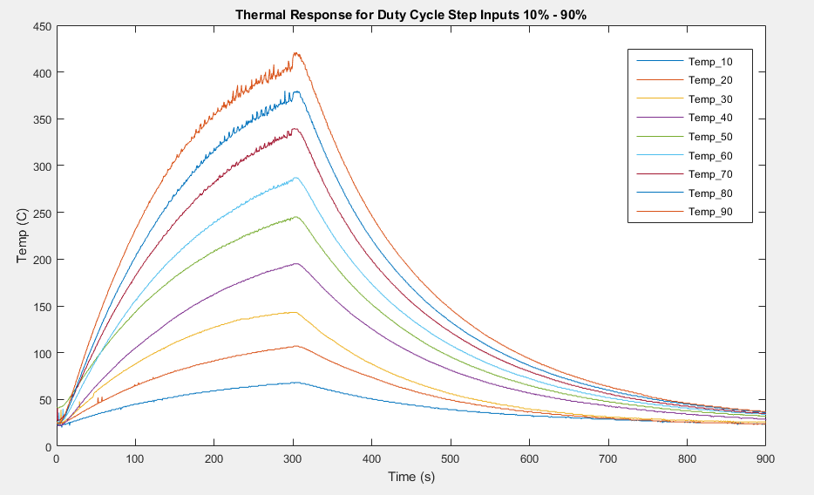

Figure : Test Data

The equation of the 90% curve was approximated using a curve fitting tool in Matlab. The Laplace Transform of the function was used to obtain an approximate model for the transfer function. Some fine tuning on the parameters led to the following Simulink model. The simulated results can be seen in Figure 3.

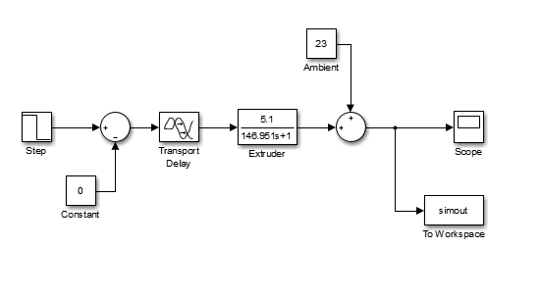

Figure : Plant Simulation

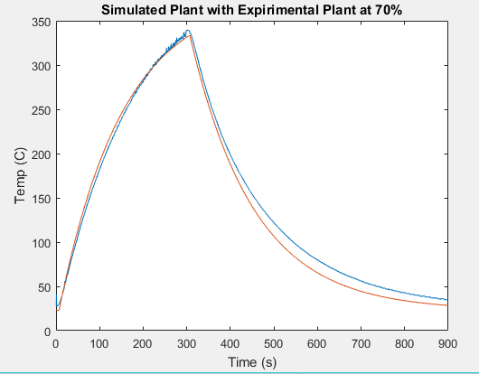

Figure : Compared Results

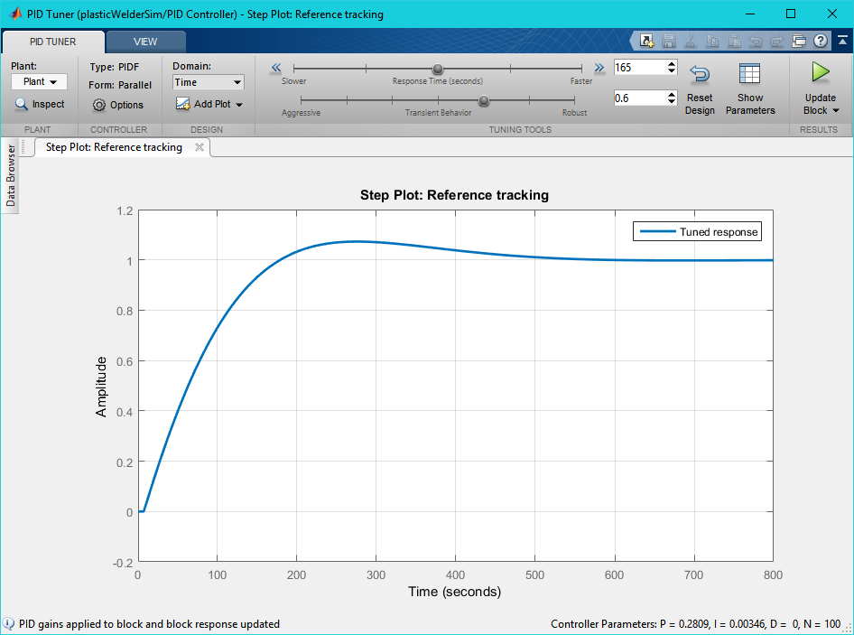

Figure : PID Tuning